

**TABLE HUB BOLIDE**

**DWS-210-001873-009**

**Custom Component Type**

**Author: Chorn an tan**

**Logitech: Newark Site**

**8 Layers PCB**

Revision and history:

|  |  |  |
| --- | --- | --- |
| Rev. | Description | Originated or modified by: |
| 001 | Initial Bolide table Hub | *Chorn An Tan* |
| 002 | Use sch TABLE_HUB_FF_VER3_011018 | *Chorn An Tan* |
| 003 | Use table_hub_ver3_2018_03_10 | *Chorn An Tan* |
| 004 | Use Sch Table_Hub_2018_04_26 | *Chorn An Tan* |
| 005 | Use Table_Hub_2018_05_11 | *Chorn An Tan* |
| 006 | Move cap ref C574 & C575 to top layer | *Chorn An Tan* |
| 007 | Use Table_Hub_2018_06_30 | *Chorn An Tan* |
| 008 | Use sch table_hub_ff_2018_07_18 | *Chorn An Tan* |
| 009 | Use sch TABLE_HUB_FF_2018_08_07_2_CHRISTIE | *Chorn An Tan* |

# Change approval management

Part owner (EE) **requests** to qualify the part also in Secondary Sample Submission

R&D **requests** that this component follow the IQC tests in any case.

As this part is a **Custom Component** type, R&D (author of this document) has to approve any revision change.

# Introduction

This document contains manufacturing specification as well as instructions for Logitech IQC inspection.

Please refer to latest panel the fabrication drawing DWS-700-013353-003 or size and dimensions

This document refers to the Gerber files GER-210-001873-009.

This specification applies for following part:

|  |  |
| --- | --- |
| **PCB Part Number** | **Revision** |
| GER-210-001873 | *009* |

For further information, please contact:

|  |  |  |
| --- | --- | --- |
| **Contact Name** | **Phone number** | **Email** |
| **Chorn An Tan** | **510-713-4592 Ext 4592** | **ctan@logitech.com** |
|  |  |  |

# PCB Manufacturing Specification

## General Details

| **Description** | **Value** | **Tolerance** |
| --- | --- | --- |
| Board Thickness (Finish) | 1.60 MM |  |
| Number of pieces per panel | *1* |  |
| Number of copper layers | 8 |  |
| Board Flammability | 94V-0 |  |
| Minimum conductor width | *0.0762* |  |
| Minimum conductor gap | *0.0762* |  |
| Maximum hole size | 4.05 mm |  |
| **Minimum hole size** | ***0.203 mm*** |  |
| Dimension of the panel | *190MMX159.40MM* |  |
| Punched or NC routing for outline | Route & Vcut |  |

## Construction Details

| **PCB Layer** | **Material** | **Thickness** |
| --- | --- | --- |
| TOP SURFACE FINISHING | *Immersion Ni/Au*  *Ni : 3-6 um Au : 0.05 um min.* |  |
| TOP COMPONENT LEGEND | White photo image |  |
| TOP SOLDER MASK | Black photo image |  |
| TOP FINISHED COPPER | Copper foil + Plating | *35um*  *( 1/2 OZ base copper + 1/2 OZ plating )* |
| INNER LAYER | Inner layer | *1 OZ* |
| BASE MATERIAL | FR-4 **TG-175** |  |
| BOTTOM FINISHED COPPER | Copper foil + Plating | *35 um* ( 1/2 OZ base copper + 1/2 OZ plating ) |
| BOTTOM SOLDER MASK | Black photo image |  |
| BOTTOM COMPONENT LEGEND | White photo image |  |
| BOTTOM SURFACE FINISHING | *Immersion Ni/Au*  *Ni : 3-6 um Au : 0.05 um min.* |  |

|  |
| --- |
|  |

## Gerber file details

Units: Imperial

Format: ***2:3*** absolute

Zero Suppression: None

No change to the Gerber files are allowed without Logitech’s approval (not even PCB manufacturer

markings)

|  |  |
| --- | --- |
| **Gerber File Name** | **PCB Layer Information** |
| 1-T-SIDE-L1.PHO | Top copper Layer 1 |
| 1-T-SILK..PHO | Silkscreen TOP |
| 1-TSMASK.PHO | Solder mask Top |
| 1-TSP.PHO | Paste mask Top |
| 2-LAYER-2.PHO | Layer 2 |
| 3-LAYER-3.PHO | Layer 3 |
| 4-LAYER-4.PHO | Layer 4 |
| 5-LAYER-5.PHO | Layer 5 |
| 6-LAYER-6.PHO | Layer 6 |
| 7-LAYER-7.PHO | Layer 7 |
| 8-B-SIDE-L8.PHO | Bottom copper Layer 8 |
| 8-B-SILK-MD.PHO | Silkscreen Bottom |
| 8-BSMASK.PHO | Solder mask Bottom |
| 8-BSP-N.PHO | Paste mask Bottom |
| 9-FABNOTE.PHO | Drill Table |
| 9-PN-OUTLINE.PHO | Panel outline |

## Drill File Details

| **Drill File Name** | **Drill Information** | **Drill Type** |
| --- | --- | --- |
| 10-DRILL.lST | Unplated holes coordinates | List |
| 10-DRILL.drl | Unplated holes | Excellon |
| 10-DRILL.REP | Drilling tools list | List |

Drill Table ( MM) :

Units: Imperial

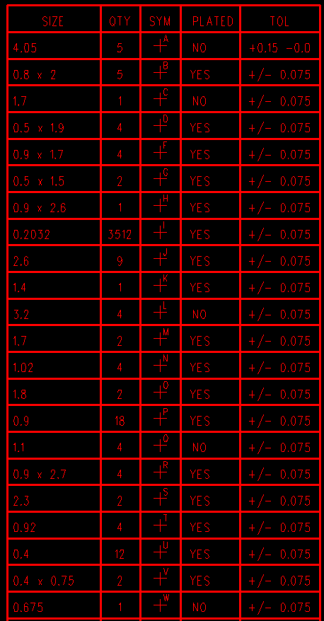

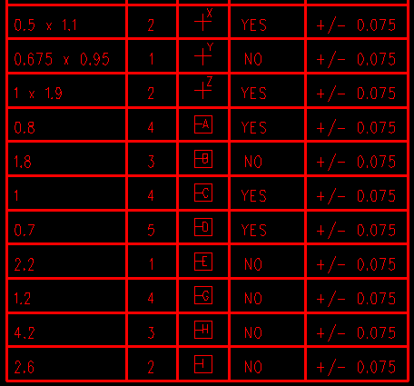

Format: ***2:3*** absolute

Zero Suppression: None

## Further Manufacturing Details

Finished boards shall be marked with the manufacturer’s company name (or trade mark), followed by type designation of UL flammability classification and date code.

## Requirements for soldering process

The material used must withstand specified Lead-Free soldering process. The minimum requirements of soldering as listed in below:

Wave soldering: 255+/-5 deg. C for 4+/-1 sec.

Hand soldering: 255+/-5 deg. C for 4+/-1 sec.

Reflow:

Peak temperature = 240 +/- 5 deg.c

TAL (Time above Liquid 217 deg.C) = 60 +/-15 sec.

This PCB adapt to which soldering process:

□ Wave Soldering

□ Reflow and hand soldering

 Double reflow and hand soldering

🞎 Hand soldering

# Logitech IQC inspection

Following sections describe the items that need to be checked on the bare PCB panels, in addition to the usual IQC checks.

## Dimensions

The dimensions of the individual boards and the panel must follow requirements included in the HW-SPEC PCBPNL, referred in Chapter 2

## Manufacturing requirements

The board must follow requirements included in the “PCB Inspection Instruction” Logitech procedure reference WWP-750816-0000.

## Impedance Control specifications

40 Ohm, 80 Ohm,100 Ohm, 90 Ohm & 50 Impedance +/- 10 % Control test is required.( check supplier’s report)

# Special requirements

## Environmental requirements

The board must follow requirements about hazardous substance included in the “Environmental Requirements: Hazardous Substance” reference STD-750779-0000. Main requirements are:

* less than 50 PPM Cd (Cadmium)
* less than 500 PPM Pb (Lead)
* less than 1000 PPM Hg (Mercury)
* less than 500 PPM Cr+6 (Chromium)
* less than 1000 PPM PBB (Polybrominated biphenyl)
* less than 1000 PPM PBDE (Polybrominated Diphenyl Ether)

## Impedance Control stack up requirement

## 

1. Reference 100 Ohm 10 % differential image show below:

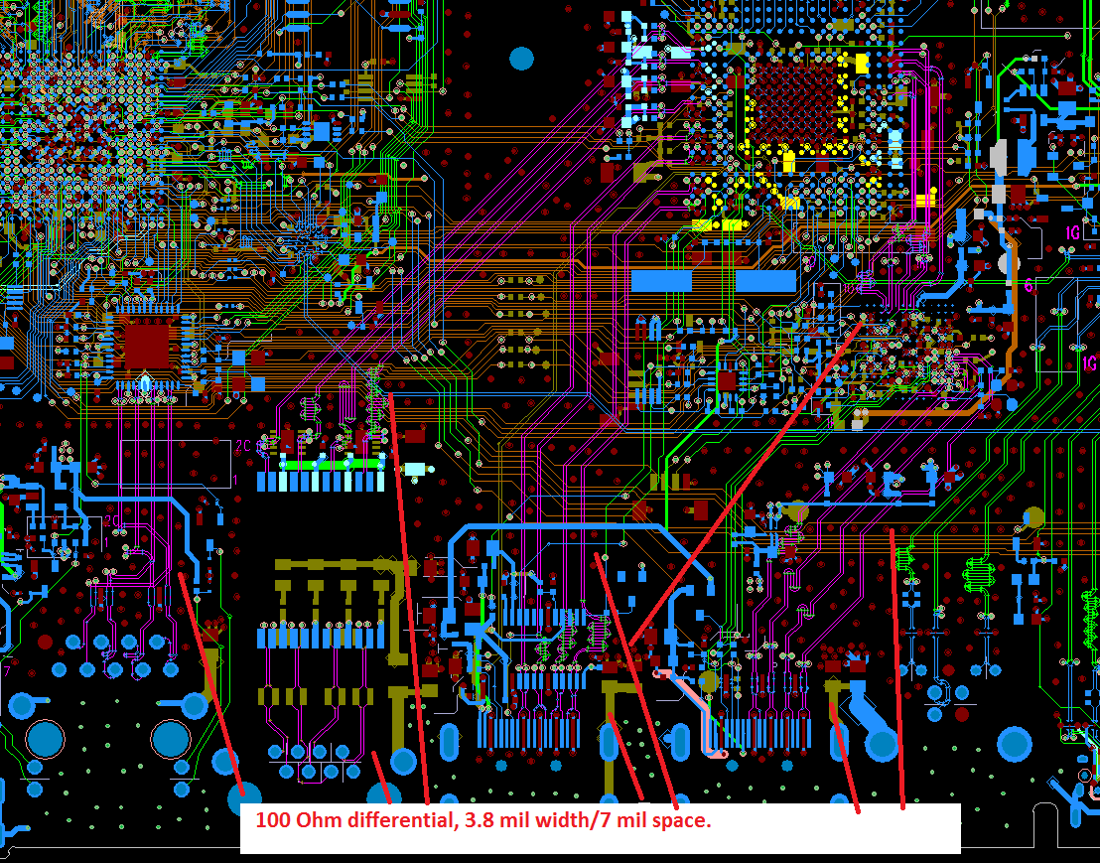

1. Reference 90 Ohm 10% differential image 2 show below

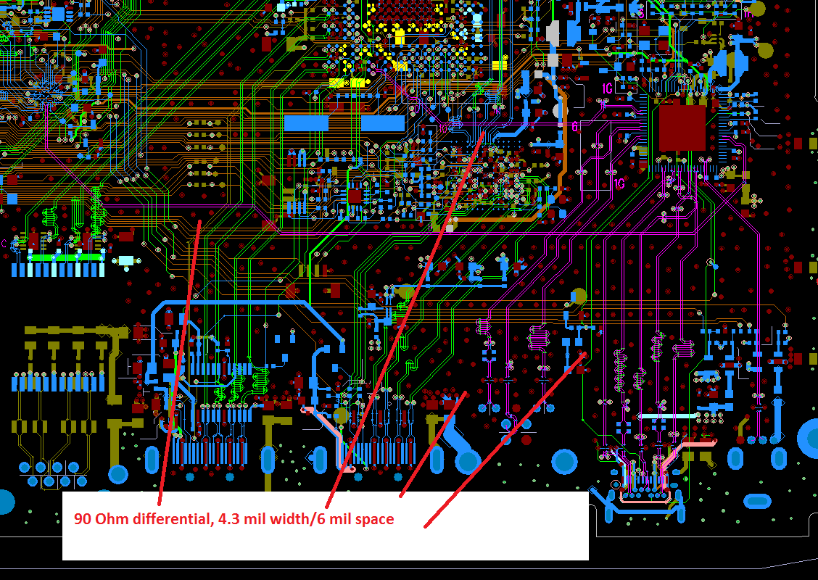

1. 4.5 mil trace, reference 50 Ohm 10 % single end image 3 show below:

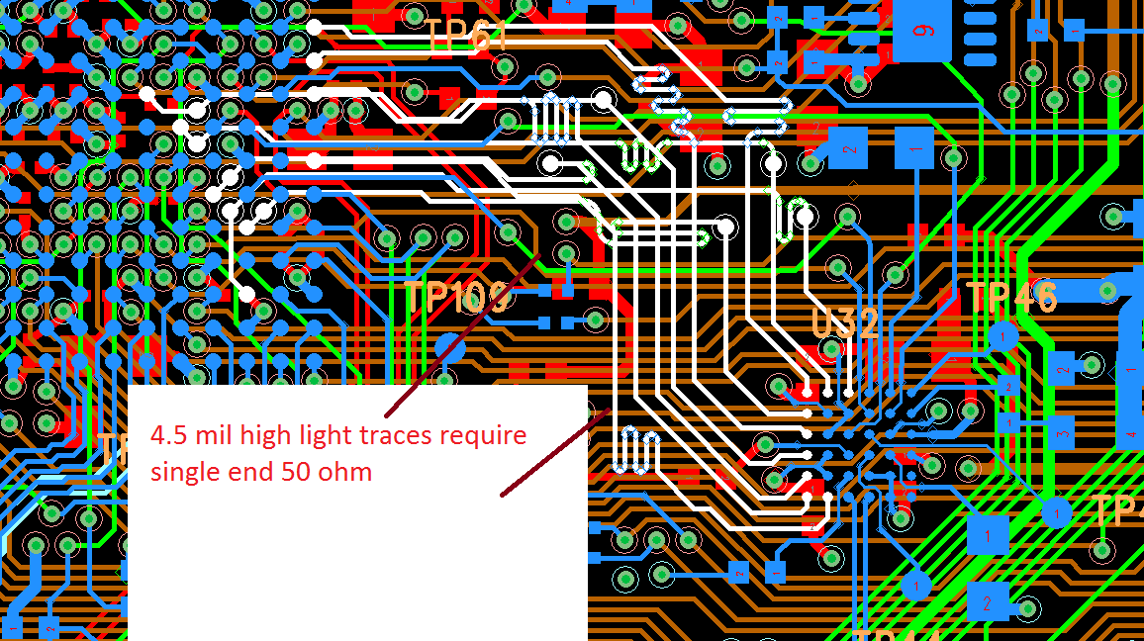

1. Reference 40 Ohm 10 % single end image 3 below:

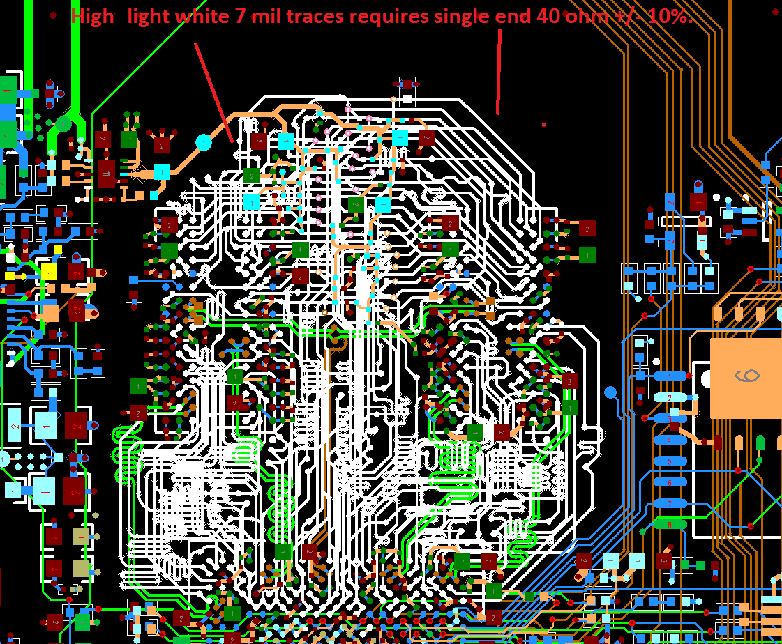

1. Reference 80 Ohm 10 % differential image 4 show belo

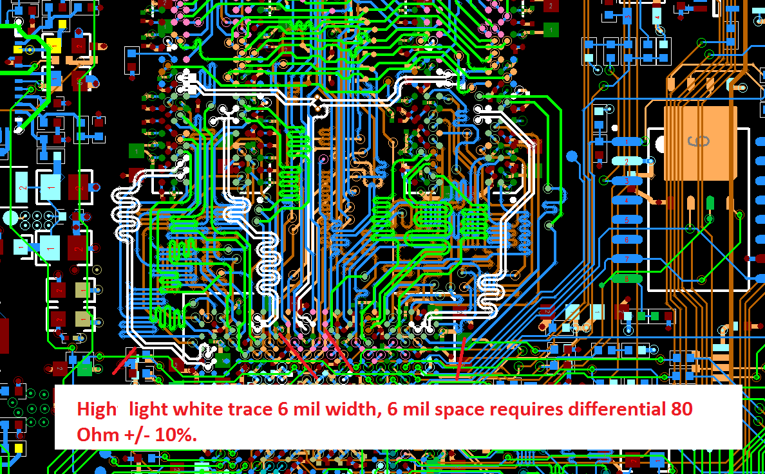

## Imaginary Copper Exposure

*The “Imaginary Copper Exposure (Golden Ring)” can not be allowable on the whole PCB.*